

**UrbanMist Chunkies**

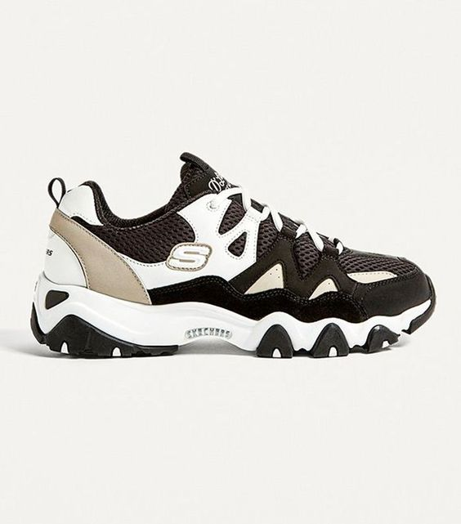

Product Details:

Color: The Skechers UrbanMist Chunkies showcase a sophisticated color palette with #c1b39e (beige), #3c352e (dark brown), #0c0803 (black), #f8f8f4 (light gray), and white.

Sole: The sole is a clean white with a touch of #2f2b27 (charcoal gray), providing stability and style.

Material: Crafted from premium synthetic materials and durable textiles for both fashion and function.

Closure: Secure lace-up closure system for a customizable and secure fit.

Branding: Skechers logo prominently displayed on the side, symbolizing the brand's authenticity and quality.

Comfort: Padded collar and cushioned insole provide exceptional comfort, making them suitable for all-day wear.

Style: The Skechers UrbanMist Chunkies offer a unique and stylish design, blending modern aesthetics with retro-inspired chunky soles.

Occasion: Versatile enough for various occasions, from casual outings to urban adventures.

Versatility: Pair with jeans, joggers, or even a casual dress for a trendy and fashion-forward look that sets you apart from the crowd